Provided by: Kentucky AGC Self-Insurers' Fund
435 N Whittington Pkwy, Suite 125
Louisville, KY 40222
Tel: (502) 415-7878

Contents
Purpose of the Guide: Why Investigate? 3
Principles of Incident Investigations 3
Important Terms 3
The Systems Approach to Investigations 4
Addressing Root Causes, Not Finding Blame 4
Establishing an Incident Investigation Program 5
Step 1: Preserve and Document the Scene 7
Step 2: Collect Information 7
Step 3: Determine Root Causes 8
Step 4: Implement Corrective Actions 9
Appendices and Additional Resources 10
Appendix A: Incident Investigation Walkthrough 11
Appendix B: Incident Investigator’s Kit 14
Appendix C: Tips for Video and Photo Documentation 15
Appendix D: Sketch the Scene Techniques 16
Appendix E: Information Collection Checklist 17
Appendix F: Sample Questions for Identifying Incident Root Causes 19

DISCLAIMER: This guide was developed by OSHA's Directorate of Training and Education and is intended to assist employers, workers and others as they strive to improve workplace health and safety. This guide is advisory in nature and informational in content. It is not a new standard or regulation and does not create any new legal obligations or alter existing obligations created by OSHA standards or regulations or the Occupational Safety and Health Act of 1970 (OSH Act). Pursuant to the OSH Act, employers must comply with safety and health standards and regulations issued and enforced either by OSHA or by an OSHA‐approved state plan. In addition, the OSH Act’s General Duty Clause, Section 5(a)(1), requires employers to provide their workers with a workplace free from recognized hazards likely to cause death or serious physical harm. Implementation of an incident investigation program in accordance with this guide can aid employers in their efforts to provide a safe workplace.

Purpose of the Guide: Why Investigate?
As a responsible employer, you need to react quickly to workplace incidents with a prescribed investigation procedure for finding root causes and implementing corrective actions. Taking quick and planned actions can demonstrate your company’s commitment to the safety and health of your employees, and your willingness to improve your safety and health management programs to prevent future incidents.
Employers should investigate all workplace incidents—both those that cause harm and the close calls that could have caused harm under slightly different circumstances. The process helps employers look beyond what happened to discover why it happened. Investigations also save employers money, as incidents are far more costly than most people realize. The National Safety Council estimates that, on average, preventing a workplace injury can save employers $39,000, and preventing a fatality can save more than $1.4 million. Employers can also save on the less obvious, but often more expensive indirect costs, such as lost production, increased administrative time, lower morale, personnel training and damaged reputation.

Principles of Incident Investigations
Employers will notice this guide uses the term “incident,” not “accident,” to describe a workplace event. This is because the word “accident” has come to be considered as a random event that could not have been prevented. However, the vast majority of harmful workplace events do not just happen. On the contrary, most harmful workplace incidents are wholly preventable.
In short, the basic principle is that incidents do not have to occur, they can be prevented by addressing shortcomings in workplace health and safety programs.

Important Terms
The following are the key terms that are used throughout this guide:
- Incident: A work-related event in which an injury, illness or fatality occurred, or could have occurred. This term is used regardless of the severity of the incident.
- Root causes: The underlying reasons why unsafe conditions exist, or why a procedure or safety rule was not followed in the workplace. Root causes generally reflect management, design, planning, organizational or operational failings. For example, a root cause could be a damaged guardrail that was routinely overlooked by supervisors to ensure the speed of production.
- Close call: An incident that could have caused serious injury or illness but did not. This is also referred to as a “near miss.”
Incident investigations that focus on identifying and correcting root causes—and not on finding fault or blame—also improve workplace morale and increase productivity by demonstrating an employer’s commitment to a safe and healthy workplace.

The Systems Approach to Investigations
Under a systems approach, investigations do not focus primarily on the behaviors of employees, but on the factors that prompted such behaviors. The goal is to change the conditions under which people work by eliminating or reducing the factors that create unsafe conditions. This is typically done by implementing adequate barriers and safeguards against the factors that cause unsafe conditions or actions.
Using this approach, an investigation should never conclude that an incident was caused only by carelessness or failure to follow a procedure. This conclusion would fail to discover the root cause of an incident and identify the systemic changes needed to prevent future incidents. Instead, when a shortcoming is identified, it is important to ask why it existed and what steps should be taken to prevent reoccurrences.

Addressing Root Causes, Not Finding Blame
Root causes often involve multiple deficiencies in workplace safety and health programs. These deficiencies may exist in areas such as workplace design, equipment maintenance, operating procedures, staffing, supervision and training. Although addressing root causes typically involves more work, it also leads to safer workplaces and is more effective at preventing reoccurrences. Eliminating the immediate causes of an incident is like cutting weeds, while eliminating the root causes is equivalent to pulling out the roots so that the weed cannot grow back.
A successful incident investigation must always focus on discovering the root causes instead of assigning blame and disciplinary action. If an investigation becomes a search for an at-fault individual, both management and employees will be reluctant to participate in an open and forthright manner.
Consider the following example: an employee has suffered an amputation while using a table saw with a broken guard. During a follow-up investigation that was concerned mainly with finding fault, a manager might ask the following questions:
- Did the employee simply make a random slip-up? Does the employee have a history of clumsiness or forgetfulness?
- Who is responsible for machine guards? Why did that person fail to notice and fix the table saw’s guard?
- Who was responsible for training the injured employee? Did a mistake or oversight during training contribute to the incident?
Note that these questions are all aimed at finding a single, at-fault individual. As a result, any resolution from this investigation would likely be limited to these individuals, and would have a negligible impact on overall safety.
Here is another list of questions that might be asked during an investigation of the same injury that followed a systems approach:
- Are there workplace procedures in place to ensure the safety of employees who operate machinery if they feel fatigued, ill or otherwise incapable of performing their duties?

- Focus on identifying root causes, and not on establishing fault.
- Emphasize correcting root causes.
- Include clear, easy-to-follow written procedures.
- Provide for training on incident investigation and company procedures.
- Include collaboration between employees, employee representatives and management.
- Provide for an annual program review to identify and correct program deficiencies and identify incident trends.

Effective Incident Investigation Programs Do the Following:
- Is there a problem with the current equipment inspection program? How is broken equipment identified so employees know not to use it?
- Are workplace policies and training procedures updated regularly? Can employees access written policies and safety materials to reference at any time?
These questions are aimed at finding the root causes of the incident and addressing shortcomings that may have contributed to an unsafe situation. Because of this, the results of this investigation are much more likely to have an impact on the safety and health of all employees.

Establishing an Incident Investigation Program
A written incident investigation program should clearly outline every employee’s duties during the aftermath of an incident and investigation. Additionally, all employees should review the written program to ensure that they are prepared to respond to incidents before they occur.
Investigations should be conducted by a team consisting of both managers and employees, as each team member will help to bring a new perspective to the investigation. Working together will also encourage all parties to take ownership of their conclusions and recommendations, and to ensure that any corrective actions are implemented in a timely manner.
After reading through your incident investigation program, your employees should be ready to do the following:
- Notify management that an incident has occurred.
- Notify OSHA that an incident has occurred if it involved a work-related fatality, inpatient hospitalization, amputation or loss of an eye.
- Call for first responders in the event of an emergency.
- Work with management to form a group to conduct an incident investigation.
- Submit recommendations from the investigation to management.

Step 1: Preserve and Document the Scene
Preserve the scene. Preserve the scene to prevent material evidence from being removed or altered. Investigators can use cones, tape or guards to ensure that unauthorized personnel do not enter the scene and tamper with evidence.
Document the scene. Document the facts surrounding the incident, such as the exact time of the incident and who witnessed it. Some facts are essential, such descriptions of any injuries, the employment status of anyone present (e.g., temporary or permanent) and the location of the incident. Investigators can also document the scene by recording video, taking photographs and sketching.

Step 2: Collect Information
Investigators should collect information by conducting interviews with witnesses, reviewing relevant documents and workplace policies, and checking any available photos or video footage of the incident.
In addition to interviews, investigators may find other sources of useful information, including the following:
- Equipment manuals
- Industry guidance documents
- Company policies and records
- Maintenance schedules, records and logs
- Training records, including communications sent to employees
- Audits and follow-up reports
- Enforcement policies and records
- Previous recommendations for corrective action
Interviews can often yield details and useful information about an incident. Since memories fade, interviews must be conducted as promptly as possible, preferably as soon as the incident site is secure and safe. The sooner a witness is interviewed, the more accurate and candid his or her statement will be.
An incident investigation always involves interviewing and possibly re-interviewing some of the same or new witnesses as more information becomes available, up to and including the highest levels of management. Investigators should question witnesses carefully to solicit as much information as possible related to the incident.
Since some questions will need to be designed around the details surrounding the incident, each interview will be a unique experience. When interviewing injured employees and witnesses, it is crucial to reduce any possible fear and anxiety and to develop a good working relationship. When conducting an interview, investigators should follow these practices:
- Conduct the interview in the language of the interviewee. Use a translator if needed.
- Clearly state that the purpose of the interview and investigation as a whole is to collect facts, not find fault.
- Emphasize that the goal is to learn how to prevent future incidents by discovering the root causes of the incident.
- Establish a climate of cooperation and avoid anything that may be perceived as intimidating or searching for someone to blame for the incident.
- Let employees know that they can have an employee representative (e.g., labor representative) present if one is available or appropriate.
- Ask the individuals to recount their version of what happened.
- Take notes, or record the interviewee’s responses if you receive permission from him or her first.
- Ask clarifying questions to fill in any missing information.
- Repeat factual information back to the interviewee and correct any inconsistencies.
- Ask the interviewee what he or she thinks could have prevented the incident.

Step 3: Determine Root Causes
Finding the root causes of an incident goes beyond the obvious or immediate factors, it is a deeper evaluation of the incident. This requires persistent searching, typically by asking questions repeatedly. Conclusions such as “an employee was careless” or “an employee did not follow safety procedures” don’t get at the root causes of an incident. To avoid these incomplete and misleading conclusions, investigators need to continue to ask “why” questions.
Investigations are not effective if they are focused on finding fault or blame. The main goal must always be to understand how and why the existing barriers against hazards failed or proved to be insufficient.
The questions listed below are examples of inquiries that an investigator may pursue to identify contributing factors that can lead to root causes:
- Why was a procedure or safety rule not followed?
- Why was equipment damaged or why did it fail to operate properly?
- Why was a hazardous condition present during an incident?
- Why was the location of equipment, materials or another employee a factor in the incident?
- Why was there a lack of personal protective equipment (PPE) or emergency equipment during the incident?
- Why were management or other workplace programs not able to prevent the incident from occurring?

Step 4: Implement Corrective Actions
Investigations will not be complete until corrective actions that address the root causes of the incident are implemented. Implementation should include improvements to the entire workplace and should be supported by both employees and senior management.
Corrective actions will be of limited preventive value if they do not address the root causes of the incident. When planning and implementing corrective actions, employers may find that some root causes will take time and perseverance to fix. However, persisting in implementing meaningful corrective actions will not only reduce the risk of future incidents, but also improve safety, employee morale and the company’s bottom line.
Specific corrective actions address root causes directly. However, some corrective actions can be general improvements to the workplace safety environment. Here are some sample corrective actions to consider:
- Develop or strengthen a comprehensive, written safety and health management program.
- Revise safety policies to clearly establish responsibility and accountability.
- Revise, purchase or contract policies to include safety considerations.
- Change safety inspection processes to include line workers along with representatives from management.
Source: OSHA’s Incident [Accident] Investigations: A Guide for Employers

Appendices and Additional Resources
Included in this guide is a set of appendices that can serve as tools for employers to use when conducting investigations:
- Appendix A: Incident Investigation Walkthrough
- Appendix B: Incident Investigator’s Kit
- Appendix C: Tips for Video and Photo Documentation
- Appendix D: Sketch the Scene Techniques
- Appendix E: Information Collection Checklist
- Appendix F: Sample Questions for Identifying Incident Root Causes
Here is a list of additional resources to consider:
- OSHA Training Institute Education Centers: www.osha.gov/dte/edcenters/index.html
- OSHA: www.osha.gov
  - OSHA’s Incident Investigation: www.osha.gov/dcsp/products/topics/incidentinvestigation/index.html
  - OSHA’s Root Cause Analysis Fact Sheet:
https://www.osha.gov/Publications/OSHA3895.pdf
- OSHA’s “$afety Pays” Program: www.osha.gov/dcsp/smallbusiness/safetypays/
- Kentucky AGC Self-Insurers' Fund: Contact us at (502) 415-7878 today to view our comprehensive safety resources. Here is just a sample of what we can offer you:
  - Personal Protective Equipment Program
  - Workplace Safety Meeting Policy
  - Lockout/Tagout Program
  - Employee Safety Incentive Policy
  - Safety Program “Quick Check”
  - Risk Summary & Coverage Checklists

Appendix A: Incident Investigation Walkthrough
Form Section
Section A: Information

Company name: _______________________________________ Date: ____________
Investigator or team name(s) and title(s):

Name Title
_________________________________ _____________________________________
_________________________________ _____________________________________
_________________________________ _____________________________________
_________________________________ _____________________________________

Section B: Incident Description/Injury Information

- Name and age of injured employee: ______________________________________________
Employee’s first language: ______________________________________________________
Employee’s job title: ___________________________________________________________
Job at time of injury: ___________________________________________________________
Type of employment: ___ Full time ___ Part time ___ Temporary ___ Seasonal
Other: _______________________
Length of time with company: ____________________________________________________
Length in current position at the time of the incident: _________________________________
Description and severity of injury: _________________________________________________
- Date and time of incident: _____________________________________________________
- Location of incident: __________________________________________________________
Note: Items 4, 5, and 6 are used for both Step 1 and Step 2.

- Detailed description of incident: Include relevant events leading up to, during and after the incident. (It is preferred that the information is provided by the injured employee.)

__________________________________________________________________________________
__________________________________________________________________________________
__________________________________________________________________________________
__________________________________________________________________________________
__________________________________________________________________________________
Use additional pages if needed.
- Description of incident from eye witnesses, including relevant events leading up to, during and after the incident. Include names of persons interviewed, job titles, and the date and time of interviews.

__________________________________________________________________________________
__________________________________________________________________________________
__________________________________________________________________________________
__________________________________________________________________________________
__________________________________________________________________________________
__________________________________________________________________________________
__________________________________________________________________________________
__________________________________________________________________________________
__________________________________________________________________________________
__________________________________________________________________________________
Use additional pages if needed.

- Description of incident from additional employees with knowledge, including relevant events leading up to, during and after the incident. Include names of persons interviewed, job titles, and the date and time of interviews.

__________________________________________________________________________________
__________________________________________________________________________________
__________________________________________________________________________________
__________________________________________________________________________________
__________________________________________________________________________________
__________________________________________________________________________________
__________________________________________________________________________________
__________________________________________________________________________________
__________________________________________________________________________________
__________________________________________________________________________________
Use additional pages if needed.

Section C: Identify the Root Causes: What Caused or Allowed the Incident to Happen?

The root causes are the underlying reasons the incident occurred, and are the factors that need to be addressed to prevent future incidents. If safety procedures were not being followed, why were they not being followed? If a machine was faulty or a safety device failed, why did it fail? It is common to find factors that contributed to the incident in several of these areas: equipment or machinery, tools, procedures, training or lack of training, and work environment. If these factors are identified, you must determine why these factors were not addressed before the incident.

__________________________________________________________________________________
__________________________________________________________________________________
__________________________________________________________________________________
__________________________________________________________________________________
__________________________________________________________________________________
__________________________________________________________________________________
Use additional pages if needed.

Section D: Recommended Corrective Actions to Prevent Future Incidents

__________________________________________________________________________________
__________________________________________________________________________________
__________________________________________________________________________________
__________________________________________________________________________________
__________________________________________________________________________________
Use additional pages if needed.

Section E: Corrective Actions Taken or Root Causes Addressed

__________________________________________________________________________________
__________________________________________________________________________________
__________________________________________________________________________________
__________________________________________________________________________________
__________________________________________________________________________________
Use additional pages if needed.

Appendix B: Incident Investigator’s Kit
The following is a sample list of items to use to conduct an incident investigation:
- Camera
- Charged batteries for portable electronics
- Video and audio recorder
- Measuring devices of various sizes
- Leveling rod
- Clipboard and writing pad
- Pens, pencils and markers
- Graph paper
- Straight-edge ruler
- Incident investigation forms
- Flashlight
- Strings, stakes and warning tape
- Photo marking cones
- Personal protective equipment (e.g., gloves, hat, eyewear, ear plugs and face mask)
- Magnifying glass
- High-visibility plastic tapes to mark off areas
- First-aid kit
- Latex gloves
- Multiple types of sampling (holding) containers with seals
- Identification tags
- Scotch, masking and duct tape
- Compass
- Carpenter’s ruler
- Hammer
- Paint stick
- Chalk
- Protractor
- Clinometer

Appendix C: Tips for Video and Photo Documentation
Note: Interviewees must be aware that they are being video recorded or photographed. It is recommended that investigators obtain written permission from the interviewee prior to the interview.
Here are some tips for video documentation:
- Record the scene as soon as possible following the incident. Doing this early on will pick up details that may be valuable to the investigation.
- Slowly scan the area 180 degrees to the left and right to establish location.
- Narrate what is being recorded, and describe objects, size, direction, location and any other details.
- If vehicles were involved, record direction of travel.
Here are some tips for photograph documentation:
- Start by taking distance shots, then move in to take closer photos of the scene.
- Take photos at different angles (e.g., from above, 360 degrees around the scene and from below) to show the relationship of objects and details, such as ends of broken rope, defective tools, drugs, wet areas or containers.
- Take panoramic photos to help present the entire scene from top to bottom and from side to side.
- Take notes on each photo. These notes should be included in the incident investigation file along with the photos.
- Identify and document the photo type (e.g., subject, weather conditions, measurements, date, time and location).
- Place an item of known dimensions in the photo to add a frame of reference and scale (e.g., a penny or pack of cards).
- Identify the person taking the photo.
- Indicate the locations where photos were taken on sketches (see Appendix D).

Appendix D: Sketch the Scene Techniques
Here are some tips for sketching the scene of an incident:
- Make sketches large—at least 8 inches by 10 inches—and clear. Also, be sure to print legibly.
- Include incident details, such as time, date, injured person, location and conditions.
- Include measurements (e.g., distances, heights and lengths) and use permanent points (e.g., a telephone pole or building) to clearly present the measurements.
- Indicate compass directions.
- Make notes on the sketch to provide additional information, such as a photo’s location and/or where people were at the time of the incident.
Note: The sketch can be used during interviews to help interviewees identify their location before, during or after the incident.
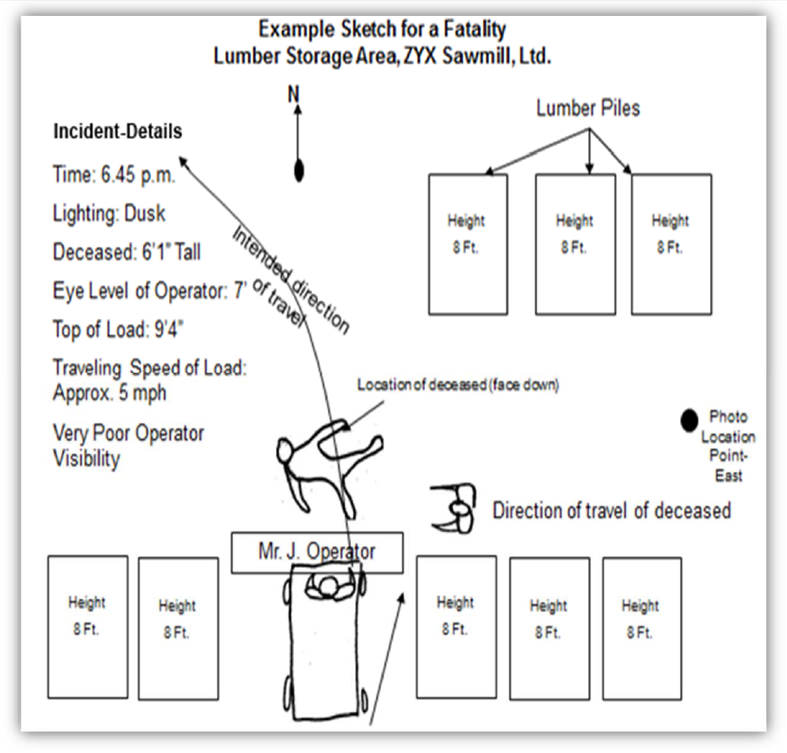

Appendix E: Information Collection Checklist
Investigators should be sure to answer the following questions:
- Who?
  - Who was injured?
  - Who saw the incident?
  - Who was working with the employee?
  - Who had instructed or assigned the employee?
  - Who else was involved?
  - Who can help prevent recurrence?
  - Where did the incident occur?
- Where?
  - Where was the employee at the time?
  - Where was the supervisor at the time?
  - Where were fellow employees at the time?
  - Where were other people who were involved at the time?
  - Where were witnesses when the incident occurred?
- What?
  - What was the incident?
  - What was the injury?
  - What was the employee doing?
  - What had the employee been told to do?
  - What tools was the employee using?
  - What machine was involved?
  - What operation was the employee performing?
  - What instructions had the employee been given?
  - What specific precautions were necessary?
  - What specific precautions were given to the employee?
  - What protective equipment should have been used?
  - What protective equipment was the employee using?
  - What had other people done that contributed to the incident?
  - What problems or questions did the employee encounter?
  - What did the employee or witnesses do when the incident occurred?
  - What extenuating circumstances were involved?
  - What did the employee or witnesses see?
  - What will be done to prevent recurrence?
  - What safety rules were violated?
  - What new rules are needed?
- Why?
  - Why was the employee injured?
  - Why wasn’t protective equipment used?
  - Why weren’t specific instructions given to the employee?
  - Why was the employee in the position?
  - Why was the employee using the tools or machine?
  - Why didn’t the employee check with the supervisor when the employee noted things weren’t as they should be?
  - Why did the employee continue working under the circumstances?
  - Why wasn’t the supervisor there at the time?
- When?
  - When did the incident occur?
  - When did the employee start on that job?
  - When was the employee assigned to the job?
  - When were the hazards pointed out to the employee?
  - When was the supervisor’s last check on job progress?
  - When did the employee first sense something was wrong?
- How?
  - How did the employee get injured?
  - How could the employee have avoided it?
  - How could fellow employees have avoided it?
  - How could the supervisor have prevented it, or could it have been prevented at all?

Appendix F: Sample Questions for Identifying Incident Root Causes
Here are some sample questions for identifying the root causes of an incident:
- Did a written or well‐established procedure exist for employees to follow?
- Did job procedures or standards properly identify the potential hazards of job performance?
- Were there any hazardous environmental conditions that may have contributed to the incident?
- Were the hazardous environmental conditions in the work area recognized by employees or supervisors?
- Were any actions taken by employees, supervisors, or both to eliminate or control environmental hazards?
- Were employees trained to deal with any hazardous environmental conditions that could arise?
- Was sufficient space provided to accomplish the job task?
- Was there adequate lighting to properly perform all the assigned tasks associated with the job?
- Were employees familiar with job procedures?
- Was there any deviation from the established job procedures?
- Were the proper equipment and tools available and being used for the job?
- Did any mental or physical conditions prevent the employees from properly performing the job?
- Were there any tasks in the job considered more demanding or difficult than usual (strenuous activities, excessive concentration required, etc.)?
- Was there anything different or unusual from normal operations (e.g., different parts, new or different chemicals used, or recent adjustments, maintenance or cleaning on equipment)?
- Was the proper personal protective equipment specified for the job or task?
- Were employees trained in the proper use of any personal protective equipment?
- Did the employees use the prescribed personal protective equipment?
- Was personal protective equipment damaged or not properly functioning?
- Were employees trained and familiar with the proper emergency procedures, including the use of any special emergency equipment and was it available?
- Was there any indication of misuse or abuse of equipment and/or materials at the incident site?
- Is there any history of equipment failure, were all safety alerts and safeguards operational, and was the equipment functioning properly?
- If applicable, are all employee certification and training records current and up to date?
- Was there any shortage of personnel on the day of the incident?
- Did supervisors detect, anticipate, or report an unsafe or hazardous condition?
- Did supervisors recognize deviations from the normal job procedure?
- Did supervisors and employees participate in job review sessions, especially for those jobs performed on an infrequent basis?
- Were supervisors made aware of their responsibilities for the safety of their work areas and employees?
- Were supervisors properly trained in the principles of incident prevention?
- Was there any history of personnel problems or any conflicts with or between supervisors and employees or between employees themselves?
- Did supervisors conduct regular safety meetings with their employees?
- Were the topics discussed and actions taken during the safety meetings recorded in the minutes?
- Were the proper resources (e.g., equipment, tools or materials) required to perform the job or task readily available and in proper condition?
- Did supervisors ensure employees were trained and proficient before assigning them to their jobs?

